Brenda C. Locke
Youth Defense Program Manager
Mississippi Office of State Public Defender

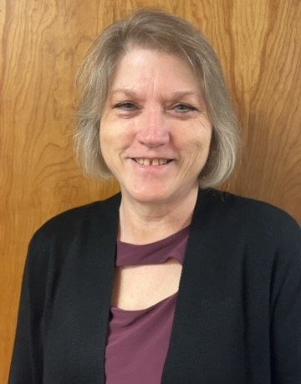
Brenda Locke is a former front-line defender who has spent the majority of her legal career advocating for the constitutional rights of youth charged with delinquent acts and status offenses in Mississippi’s youth courts. She served nearly 15 years in Jackson County, Mississippi as a public defender representing youth charged with delinquent acts in youth court and adults charged with felony crimes in circuit court. In 2012, Brenda left front-line defense and joined the Mississippi Office of State Public Defender where she served part-time as their Juvenile Resource Attorney. In this capacity she planned statewide juvenile defender trainings, was frequently a presenter at juvenile defender conferences and provided technical assistance to juvenile public defenders across the state. In January of 2023 Brenda decided to return to working directly with youth. She joined a non-profit organization and served as a case manager for at-risk youth involved in the juvenile justice system in Washington Parish, Louisiana.
On July 1, 2024, Brenda rejoined the Mississippi Office of State Public Defender, full-time, as their new Youth Defense Program Manager. In this capacity, Brenda assists with providing training for youth defenders, provides technical assistance for youth defenders and advocates to ensure that the constitutional rights espoused in In re Gault are guaranteed for all youth involved in the Mississippi youth court system. Brenda is a Certified Youth Defender Advocacy Program Trainer (YDAP) and is currently a member of the Gault Center Southern Region Advisory Committee. Brenda received her Bachelor of Science degree in Paralegal Studies from the University of Southern Mississippi in 1989 and her Juris Doctor from the University of Mississippi School of Law in 1996. She was admitted to the Mississippi Bar in 1996.

